## Question 1

1. Sub-sampling the image changes the image resolution, since for each sub-sampling ratio, we skip pixels in the x and y direction based on the ratio. Figures 1 to 4 show the results obtained for each sub-sampling ratio.



Figure : Sub-sampling 2:1



Figure : Sub-sampling 4:1



Figure : Sub-sampling 8:1



Figure : Sub-sampling 16:1

1. Figures 5 to 8 show the results obtained via quantization. As can be seen, 1 and 2 bit quantization gives false contours.



Figure : 1 bit quantization



Figure : 2 bit quantization



Figure : 4 bit quantization



Figure : 6 bit quantization

1. It was observed that the perceived image quality differed greatly when having SNR as -30, -10, 0, 10 and 30 dB. The resulting image in these three cases are shown in figures 9, 10, 11, 12 and 13 respectively.



Figure : Gaussian noise with SNR = -30dB



Figure : Gaussian noise with SNR = -10dB



Figure : Gaussian noise with SNR = 0dB



Figure : Gaussian noise with SNR = 10dB



Figure : Gaussian noise with SNR = 30dB

1. The resulting image obtained by corrupting the pixels with i.i.d noise for impulse probability 0.1, 1, 5 and 10 percent is shown from figures 14 to 18 respectively. To calculate the SNR, the Pnoise was calculated by squaring each entry in the noise matrix and summing the result. Pimage was calculated in a similar manner, and the two powers divided by each other to arrive at the SNR. Log10 of this result was taken and then multiplied by 10 to arrive at SNR in dB. For 0.1 probability, the SNR = 30.81 dB. For 1 probability, SNR = 21.07 dB. For 5 probability, SNR = 14.17 dB. For 10 probability, SNR = 11.16 dB.



Figure : probability iid = 0.1%



Figure : probability iid = 1%



Figure : probability iid = 5%



Figure : probability iid = 10%

1. The Gaussian noise seems to add black pixels as noise in the image, whereas the iid one seems to add white pixels.

## Question 2

1. It was observed that with higher values of N, the blurring intensity increases. Figure 18 shows the image blurred with N = 20 and figure 19 shows the image blur with N = 5.



Figure : blur image with N = 20



Figure : blur image with N = 5

1. For this test, the SNR for Gaussian blur was set as 10dB and the resulting image is given in Figure 12. Figure 20 shows the result obtained when applying a 3 by 3 low pass filter on the noisy image. Figure 21 shows the result obtained by applying 5 by 5 low pass filter on the image.



Figure : 3x3 low pass filter on image with Gaussian noise. SNR = 10dB



Figure : 5x5 low pass filter on image with Gaussian noise. SNR = 10dB

1. For this experiment, the probability of iid impulse was set as 10%, where the resulting noisy image is shown in figure 17. The result obtained by applying 3 by 3 low pass filter on this noisy image is shown in figure 22 and the result of 5 by 5 filter is shown in figure 23. This approach works because it blurs out the iid impulse created on the image, therefore fixing the noise.



Figure : 3x3 low pass filter on image with iid noise. Piid = 10%



Figure : 5x5 low pass filter on image with iid noise. Piid = 10%

1. The result obtained by applying the 3 by 3 median filter is shown in figure 24, while figure 25 shows the result of 5 by 5 median filter. This filter takes the median of every 3-by-3 subsection of the image and therefore, it would average out the iid impulse encountered in most cases.



Figure : 3x3 median filter



Figure : 5x5 median filter

1. Applying the high pass filter on the image gives the resulting image of figure 26. This seems to have inverted the intensity of pixels in the image, therefore giving a highlight effect.



Figure : High pass filter result

## Question 3

1. Figure 27 shows the 2-D fft plot result on the original image. **Frequencies up till 500Hz are present?? SHorouq!!!!**

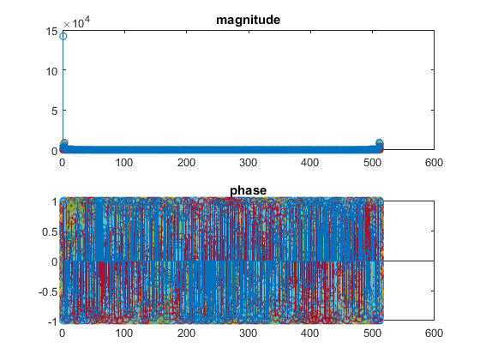

Figure : 2D FFT plot of Mandrill image